**Social engineers shortcuts to trust:**

* **Authority**
* **Familiarity/company specific jargon**
* **Name dropping**
* **Shoulder surfing/dumpster diving**

**Supply Chain Attacks**

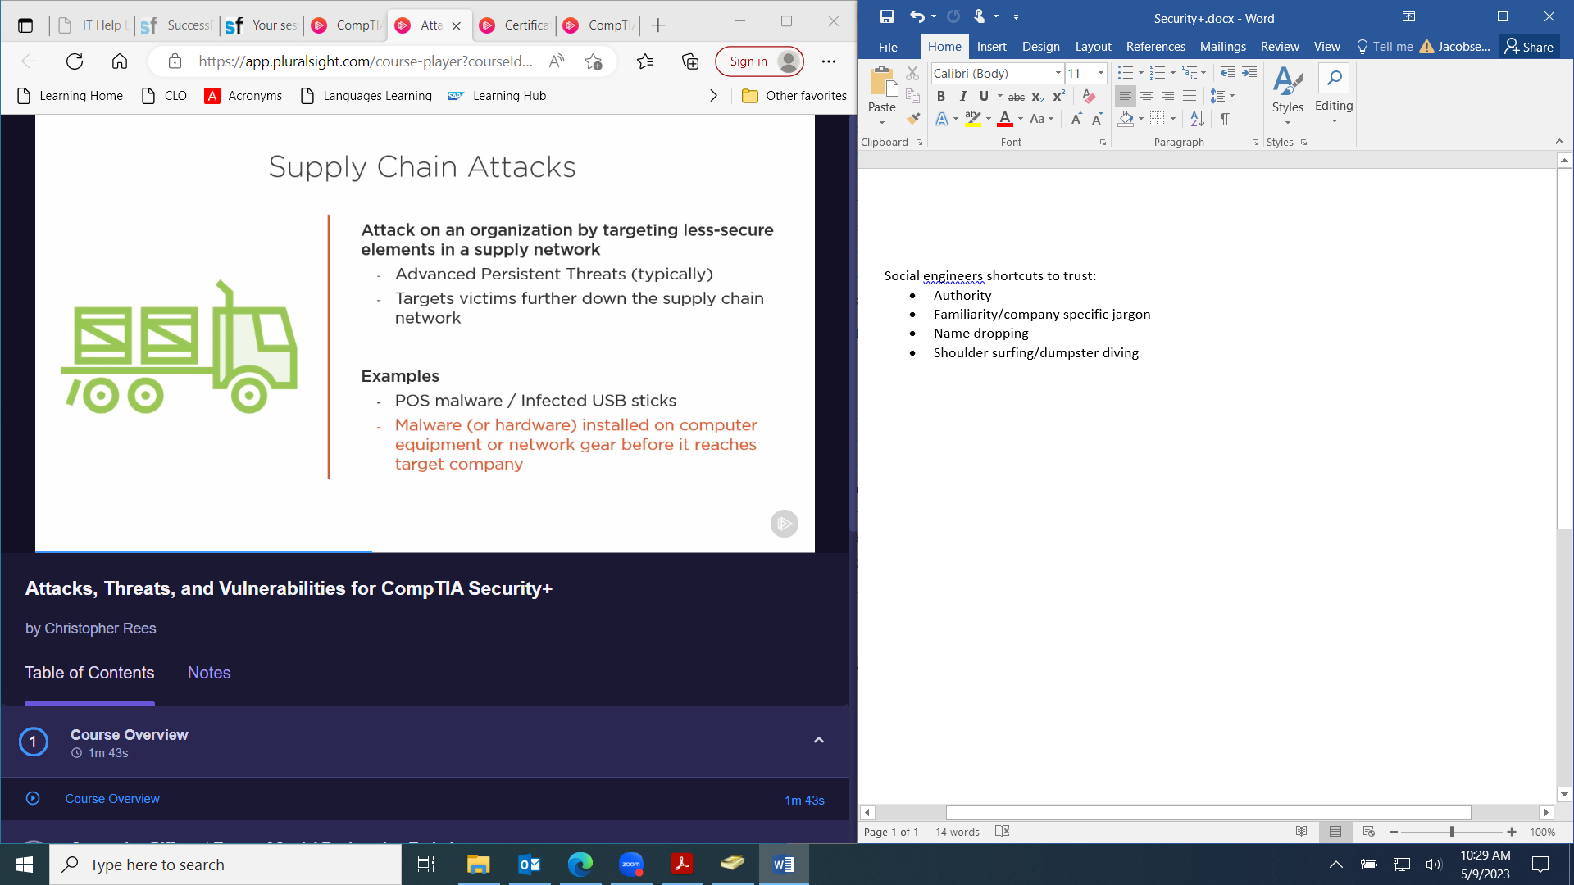

**Social Engineering**

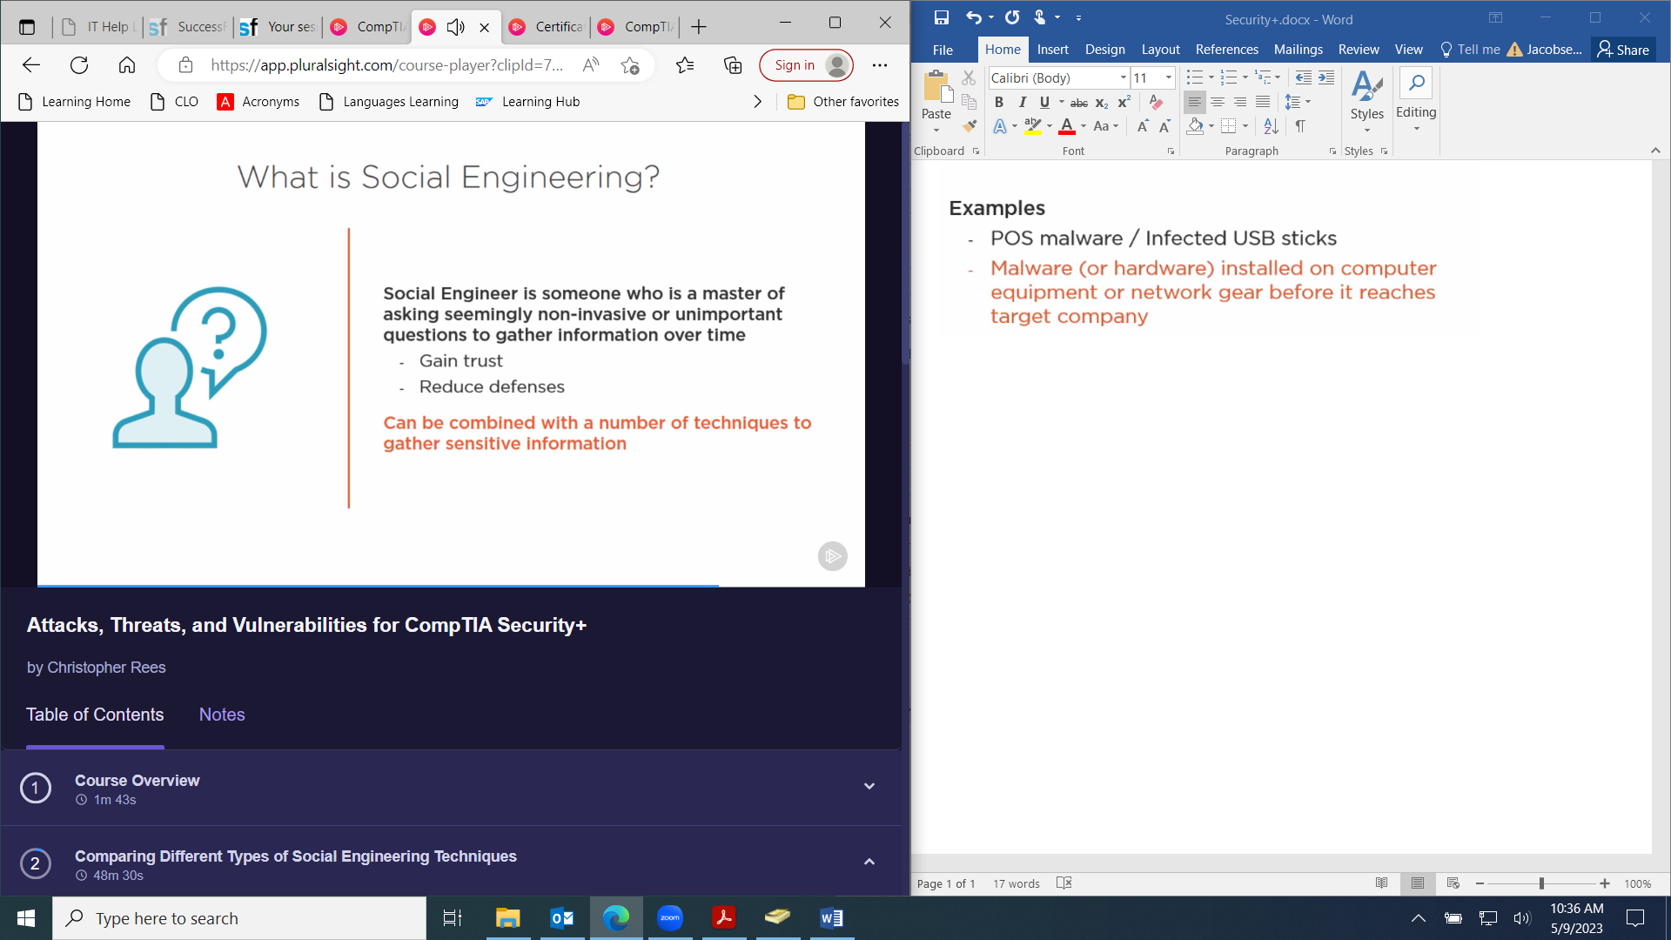

**Phishing**

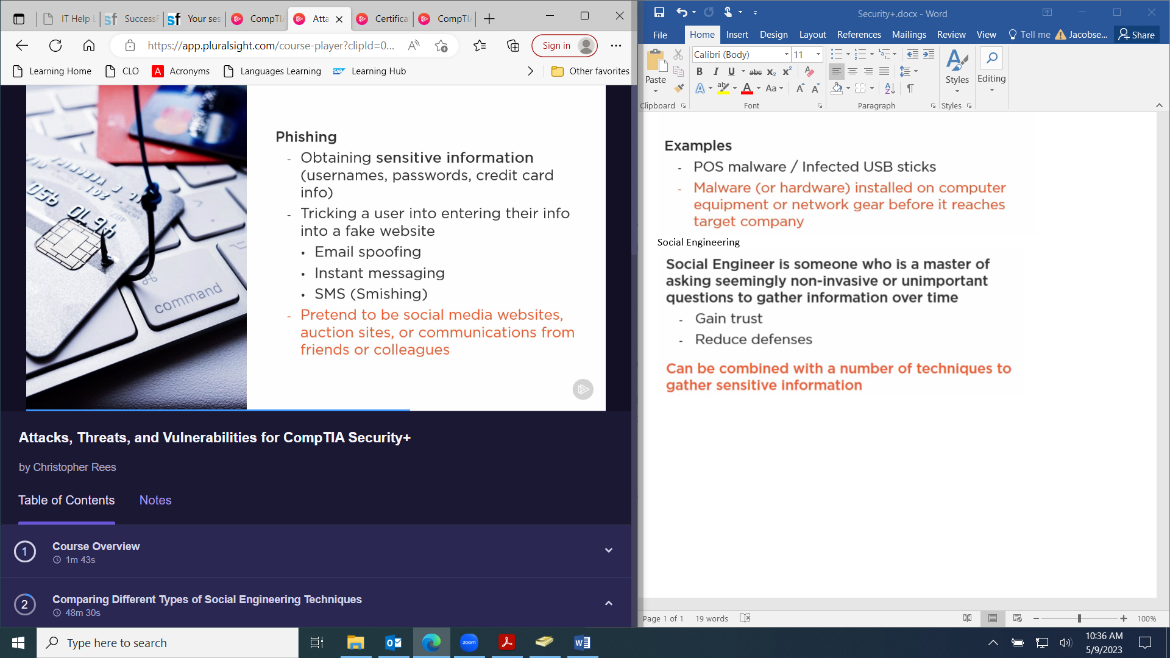

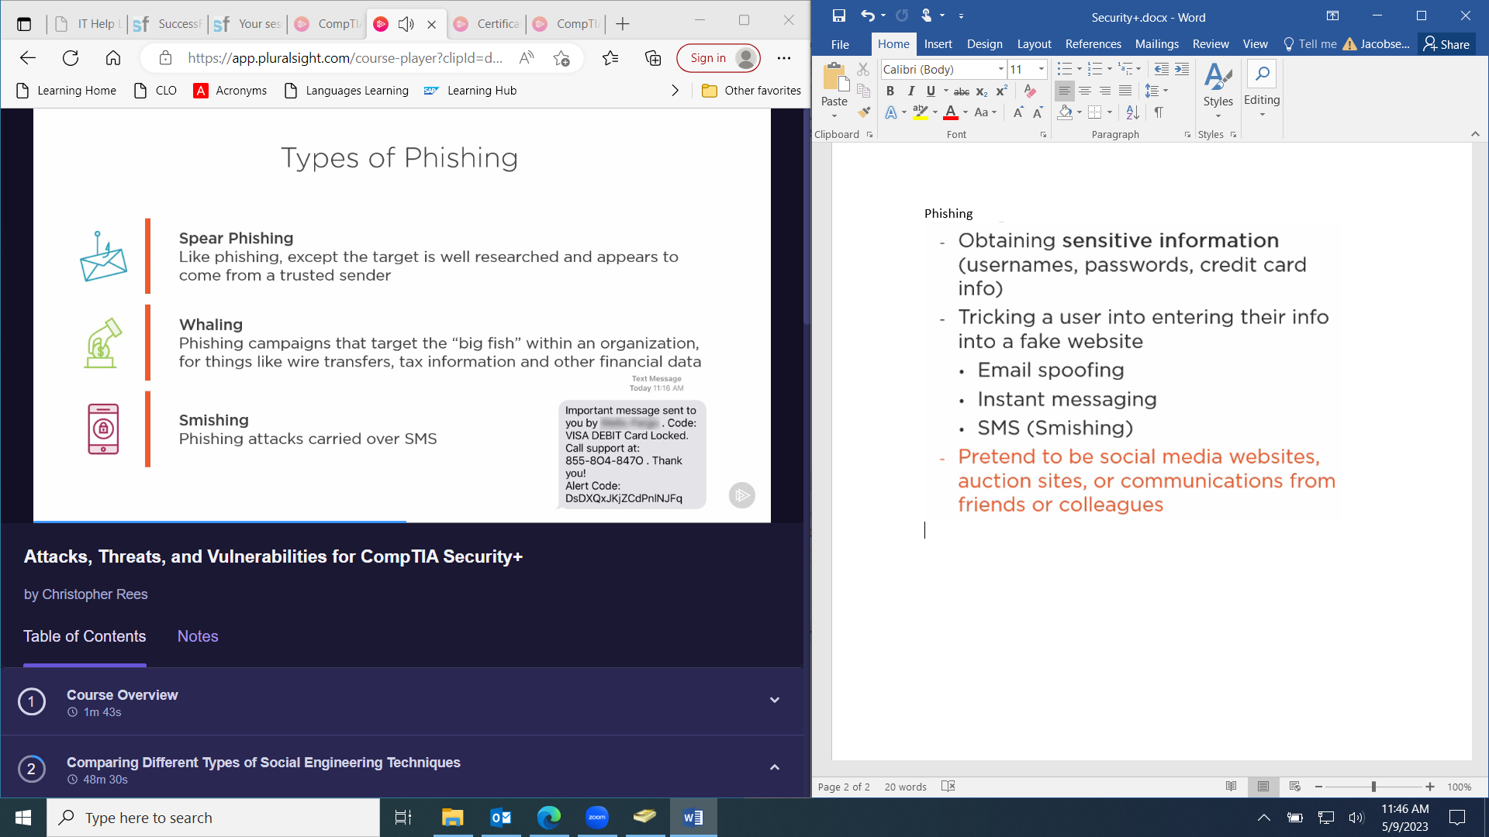

**Vishing: Voice phishing.**

**SPIM: SPAM over Instant Messaging.**

**Credential Harvesting**

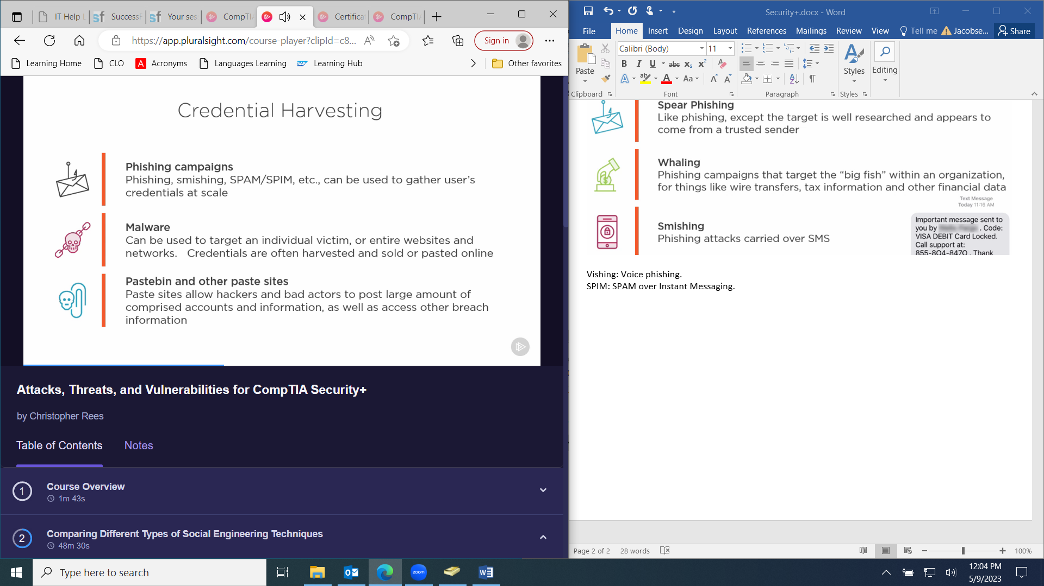

**Watering Hole Attack**

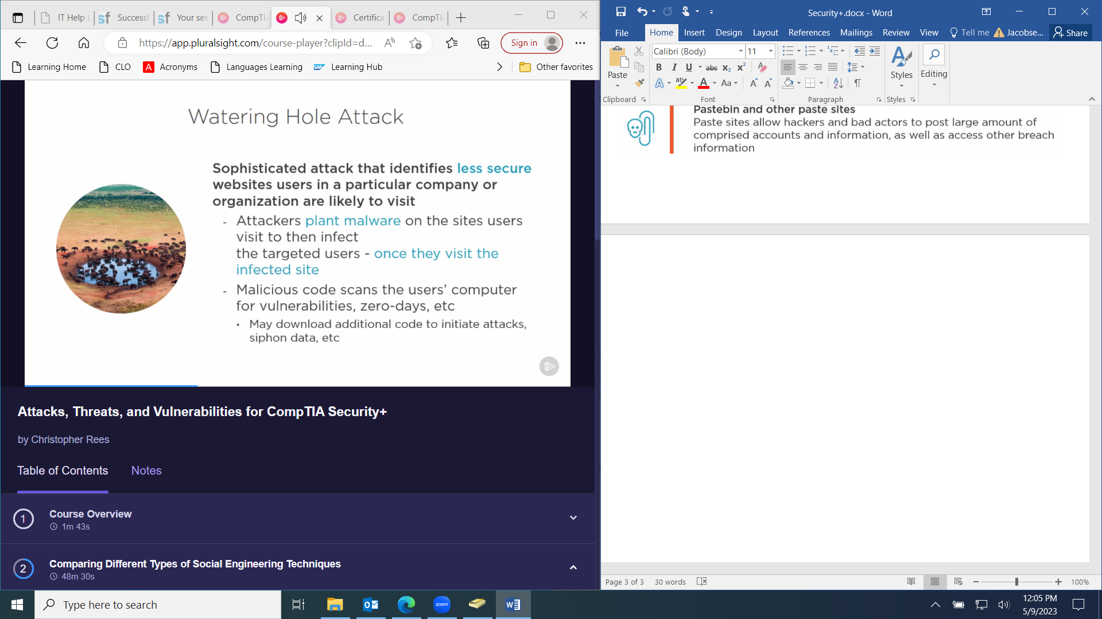

**Indicator of Compromise (IoC): Artifacts observed that indicate (with a high degree of confidence) a computer intrusion.**

* **Unusual outbound network traffic**
* **DNS request anomalies**
* **Mismatch port-application traffic**
* **Anomalies in privileged user account activity**

**Virus: Malicious code that requires user interaction to install and replicate.**

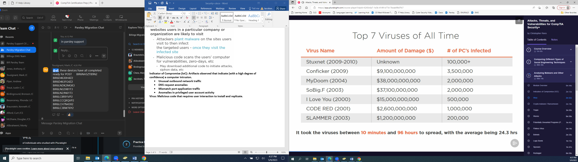

**Crypto-Malware / Ransomware**

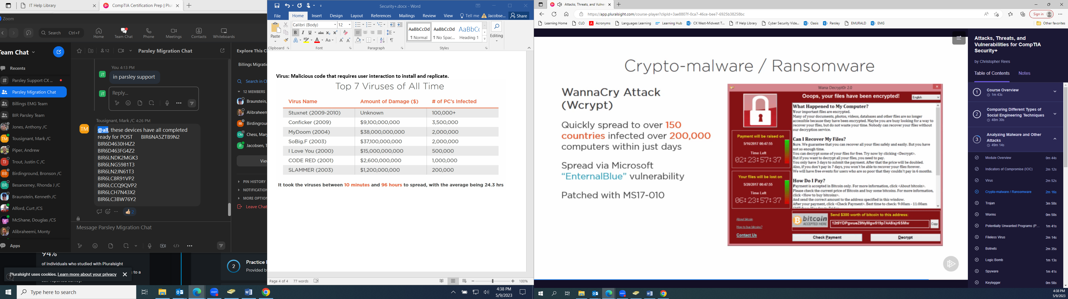

**Trojan: Seemingly friendly software that contains hidden malicious software**

**Remote Access Tool (RAT)**

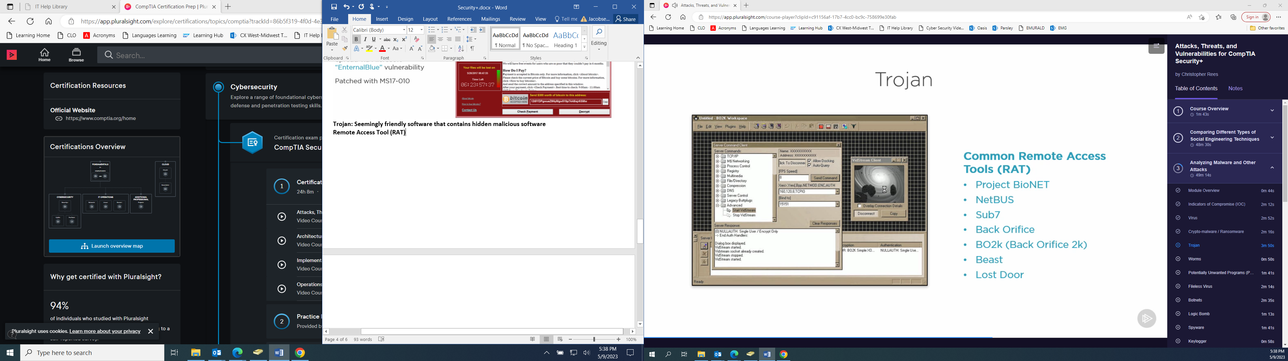

**Binding: The act of tweaking or attaching known malicious code to another program to sneak past anti-malware/virus tools that typically stop or block such programs**

**Worms**

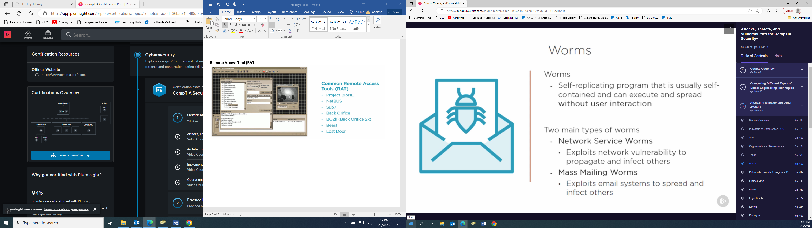

**Potentially Unwanted Program (PUP): Applications that are typically downloaded as part of another program (adware, spyware, etc.)**

**Fileless Virus: Malware that operates in memory.**

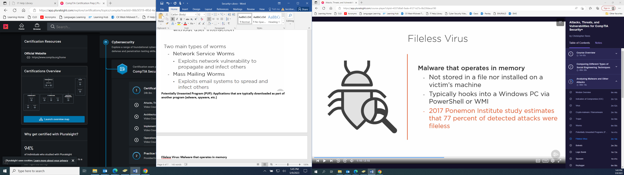

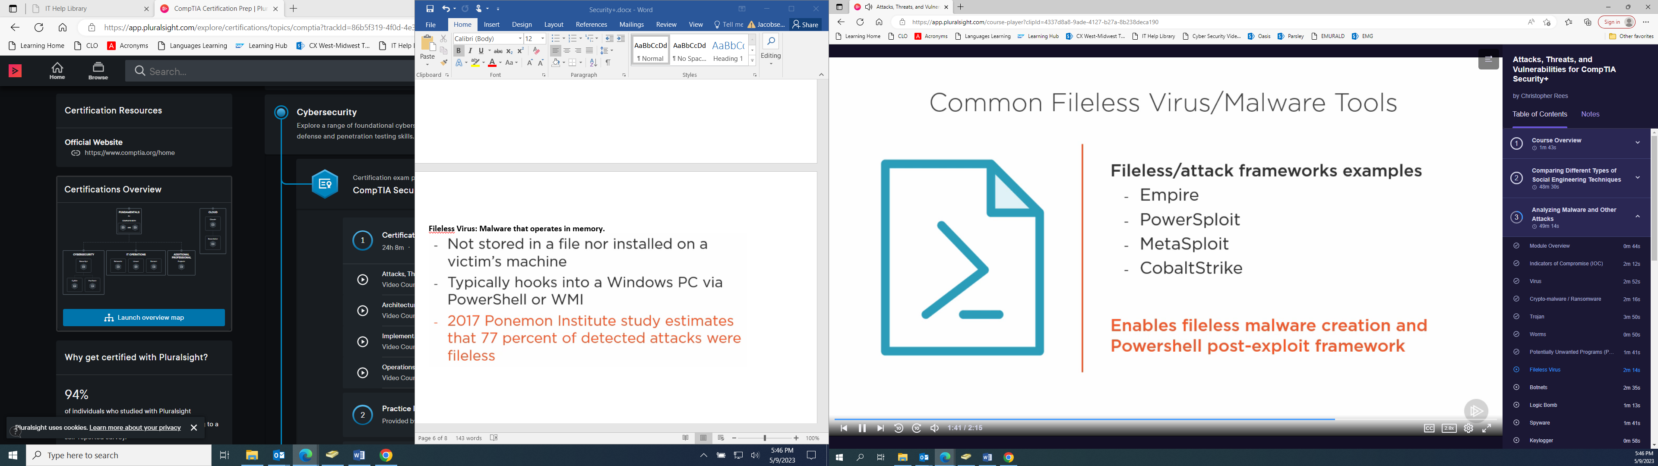

**Botnets**

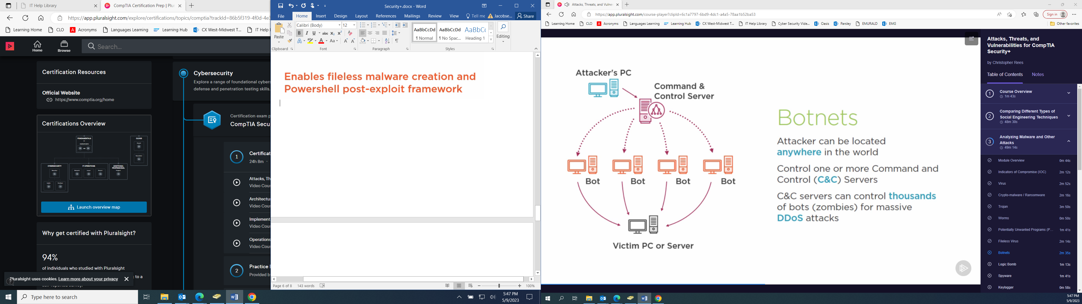

**Logic Bomb: Malicious code that triggers after a period of time based on some date or specific activity.**

**Spyware: Malicious software that captures user activity (keystrokes, web browsing, etc) and reports back.**

**Keylogger: Malicious application or device that can capture all keystrokes.**

**Rootkits: Malicious code that installs itself at the OS or Kernel level to avoid detection.**

* **Loads before OS**
* **Can disable anti-virus and anti-malware**
* **TDSSKiller by Kaspersky can detect and deal with some rootkits**

**Backdoors: Software that installs for the purpose of opening ports and installing additional software. Backdoors can:**

* **Phone home, steal credentials, be a keylogger**
* **They can install from applications, exes, and images**
* **Download additional software or allow remote access**

**Rainbow Tables**

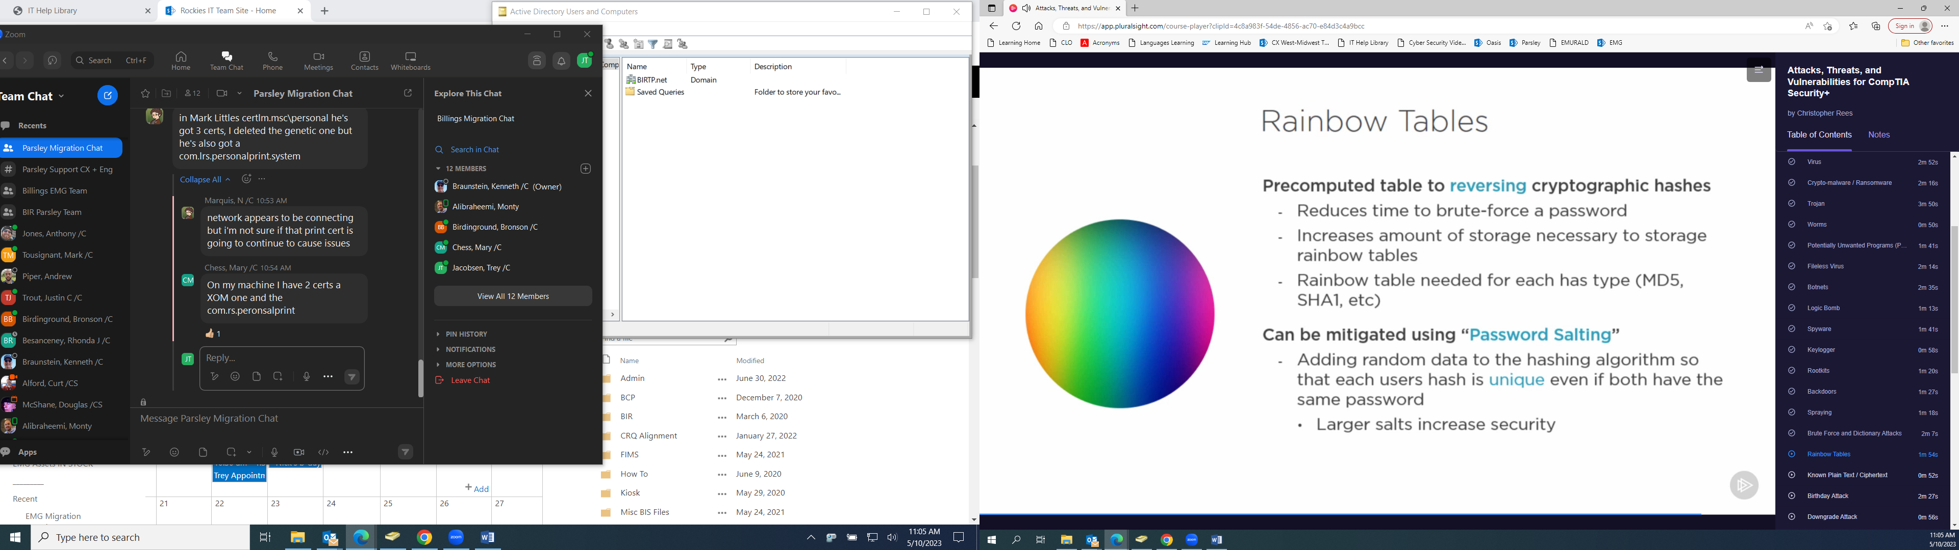

**Known Plain Text / Ciphertext**

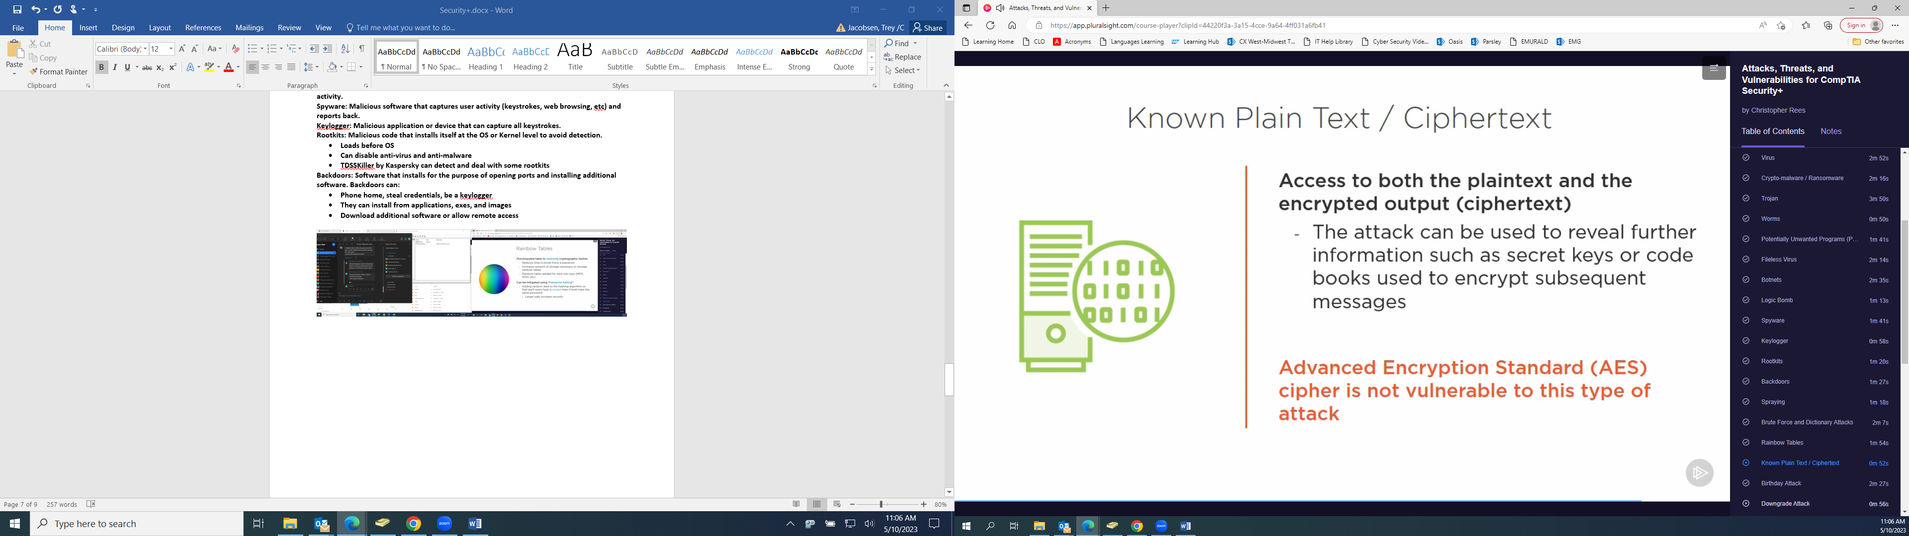

**Birthday Attack**

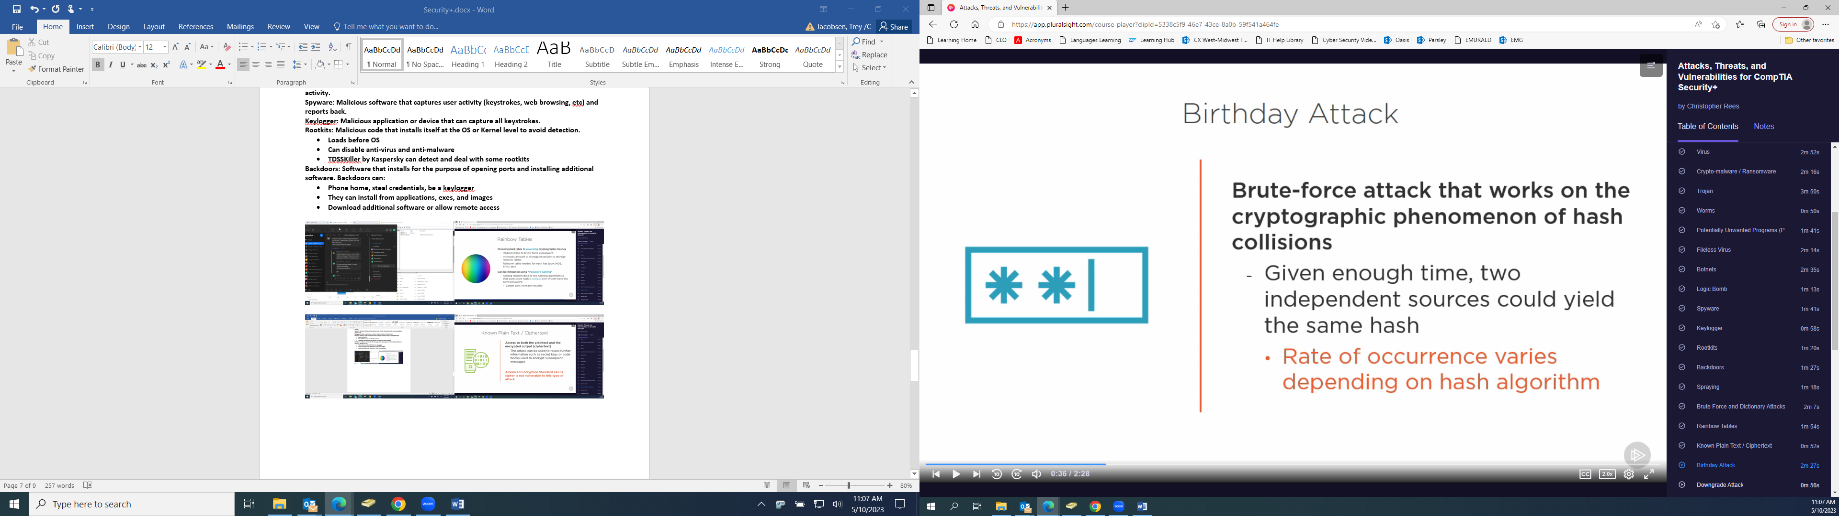

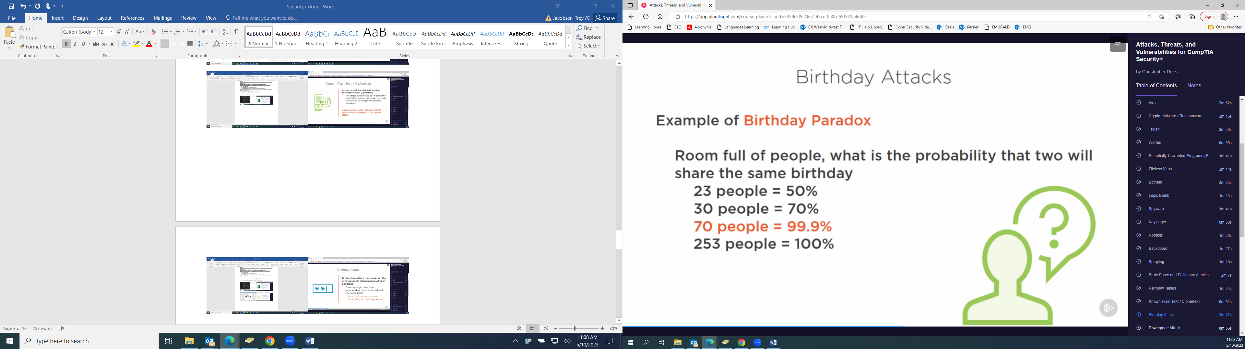

**Downgrade Attack**

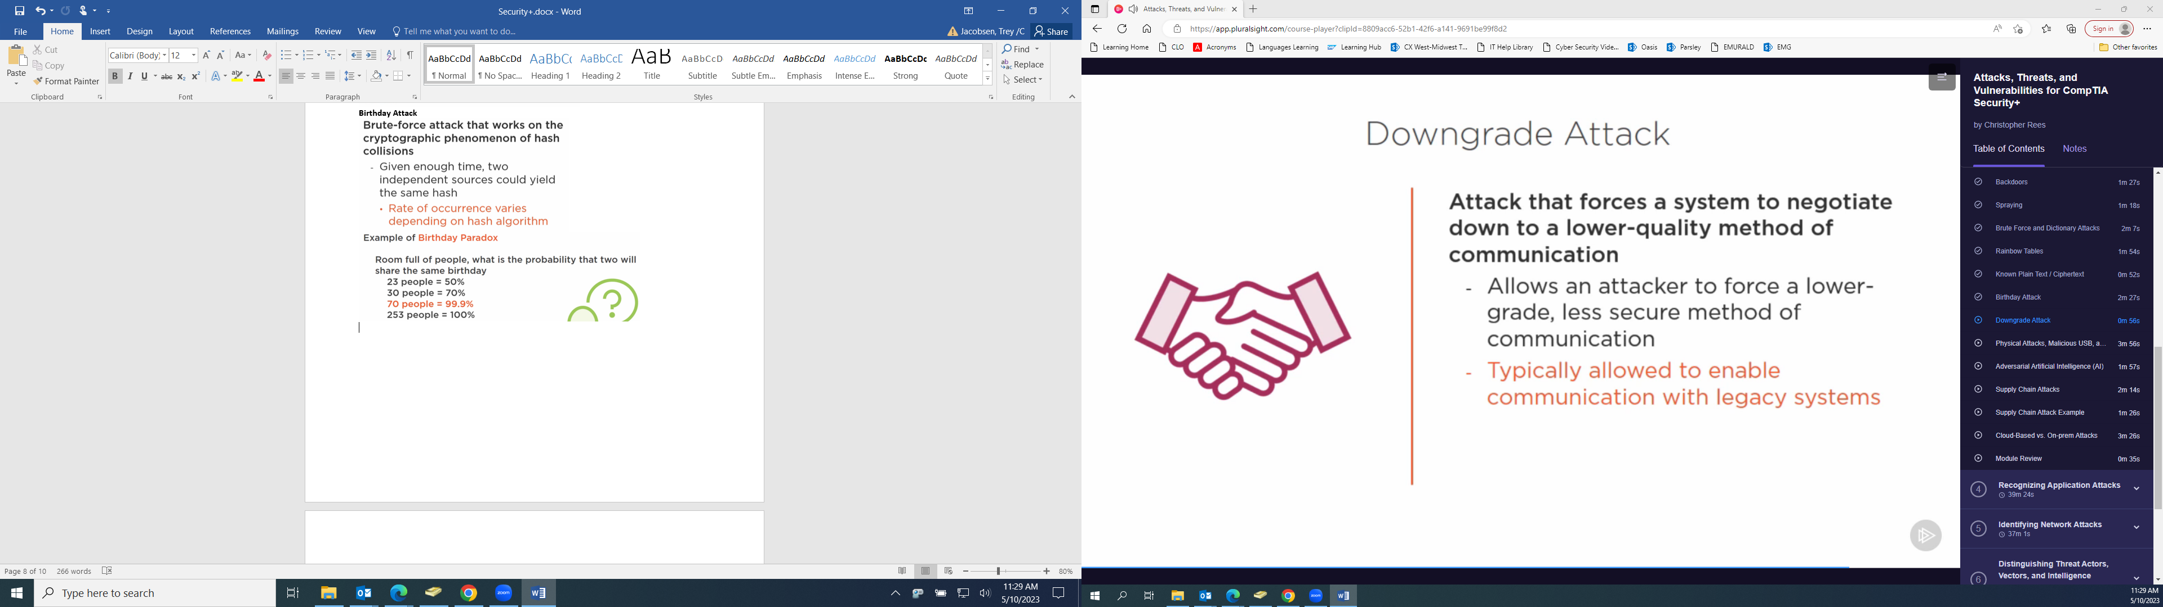

**Physical Attacks**

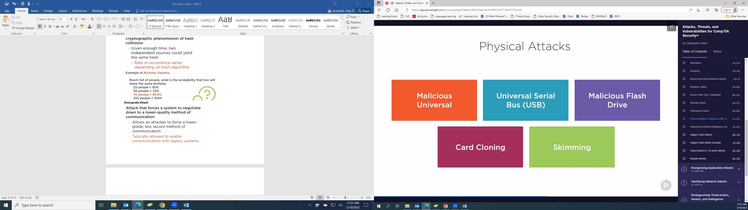

**Skimming involves fake card readers**

**Adversarial AI:**

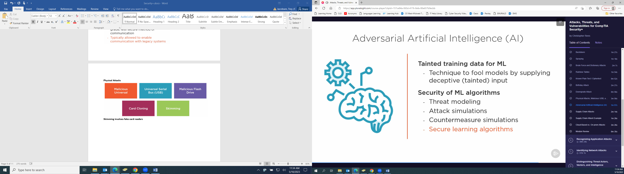

**Supply Chain Attacks**

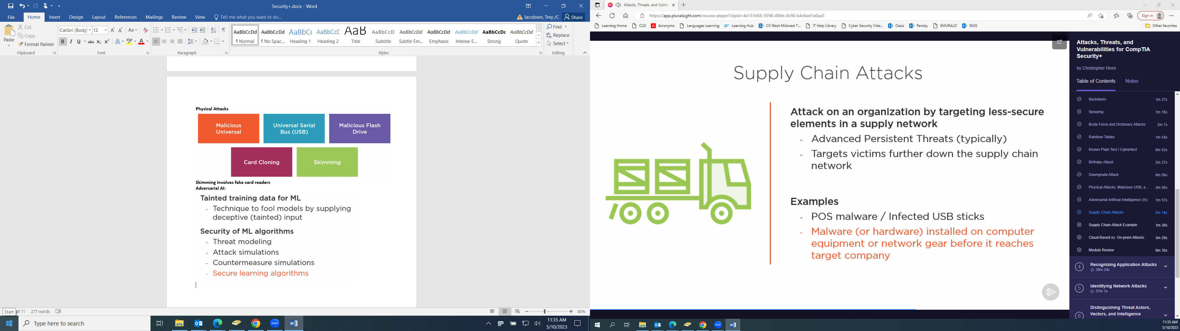

**Privilege Escalation**

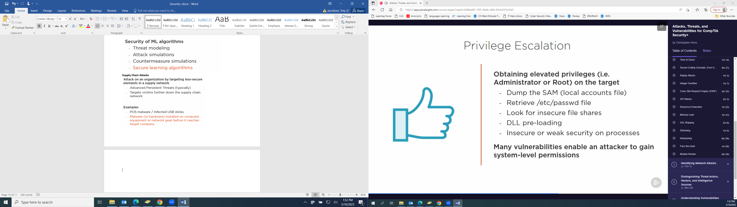

**Cross Site Scripting (XSS)**

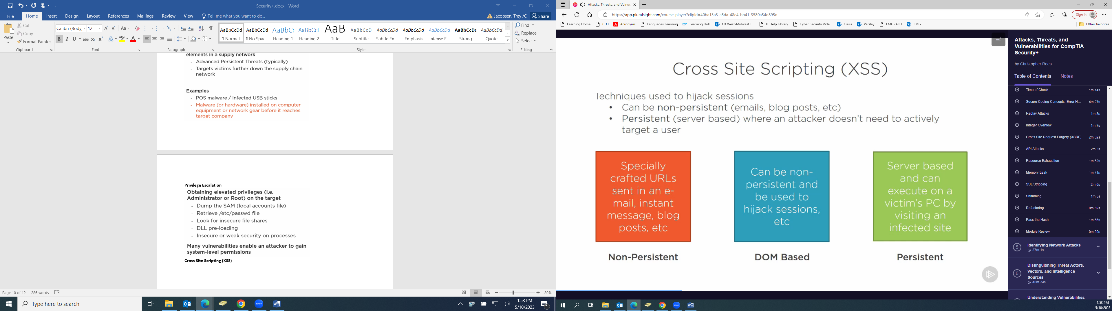

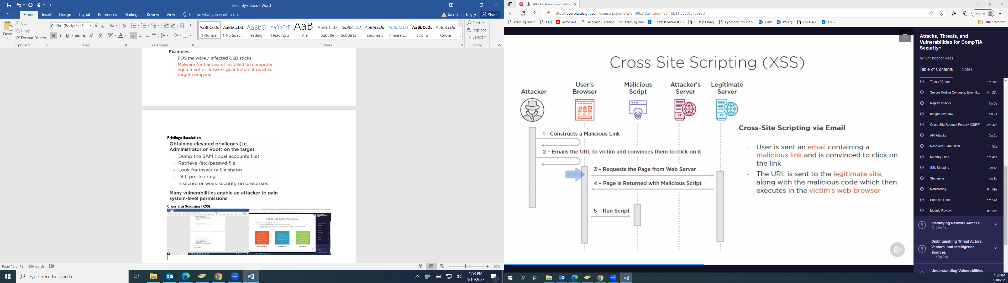

**SQL Injection**

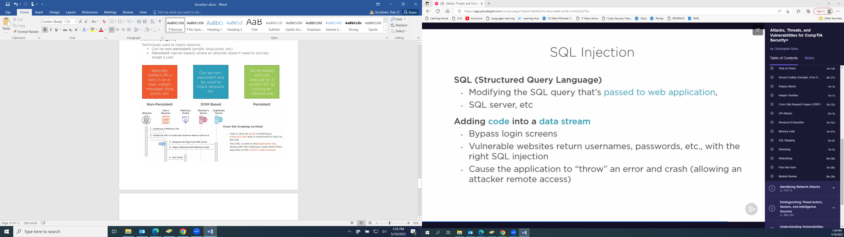

**DLL Injection**

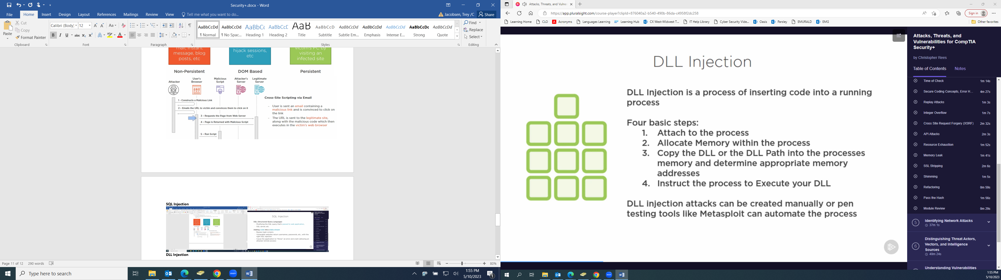

**LDAP Injection**

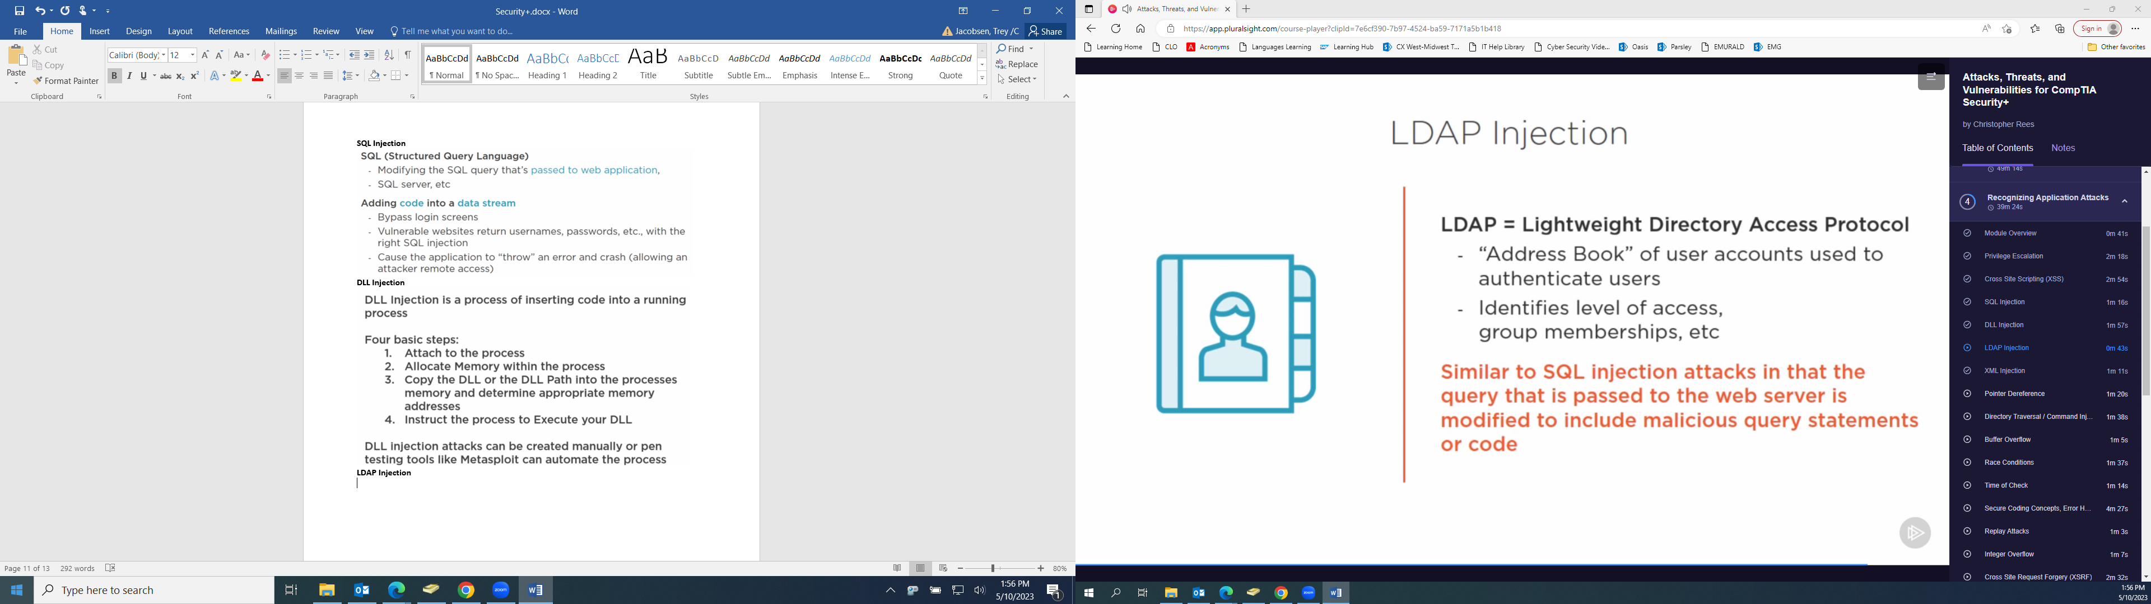

**XML Injection**

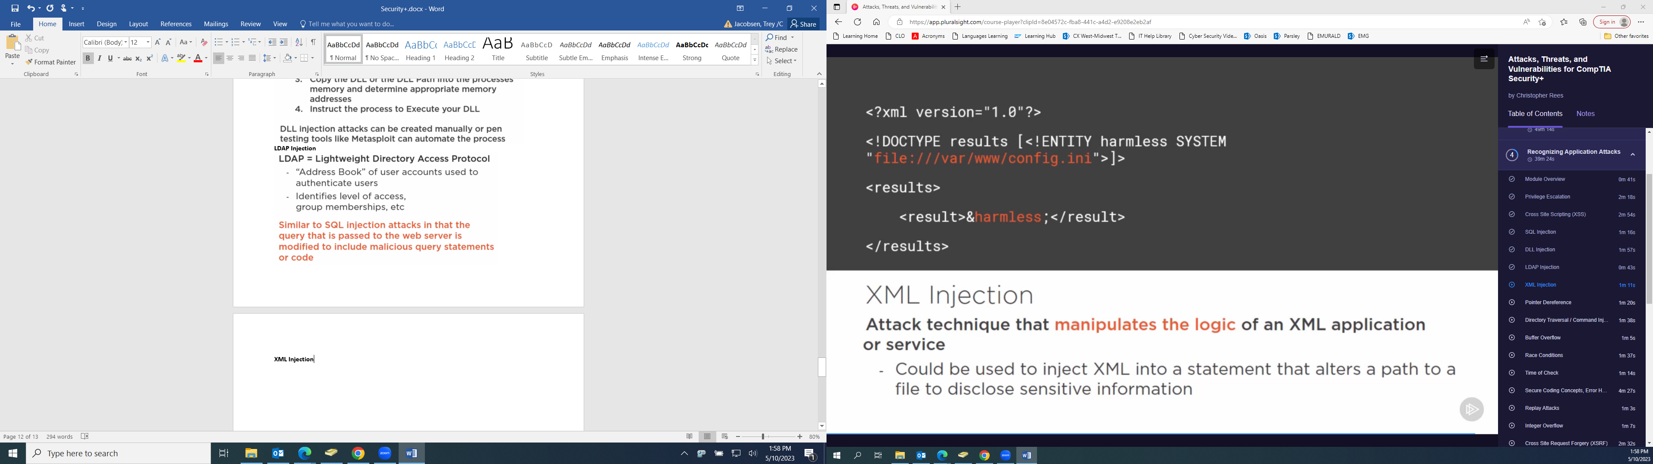

**Pointer Dereference**

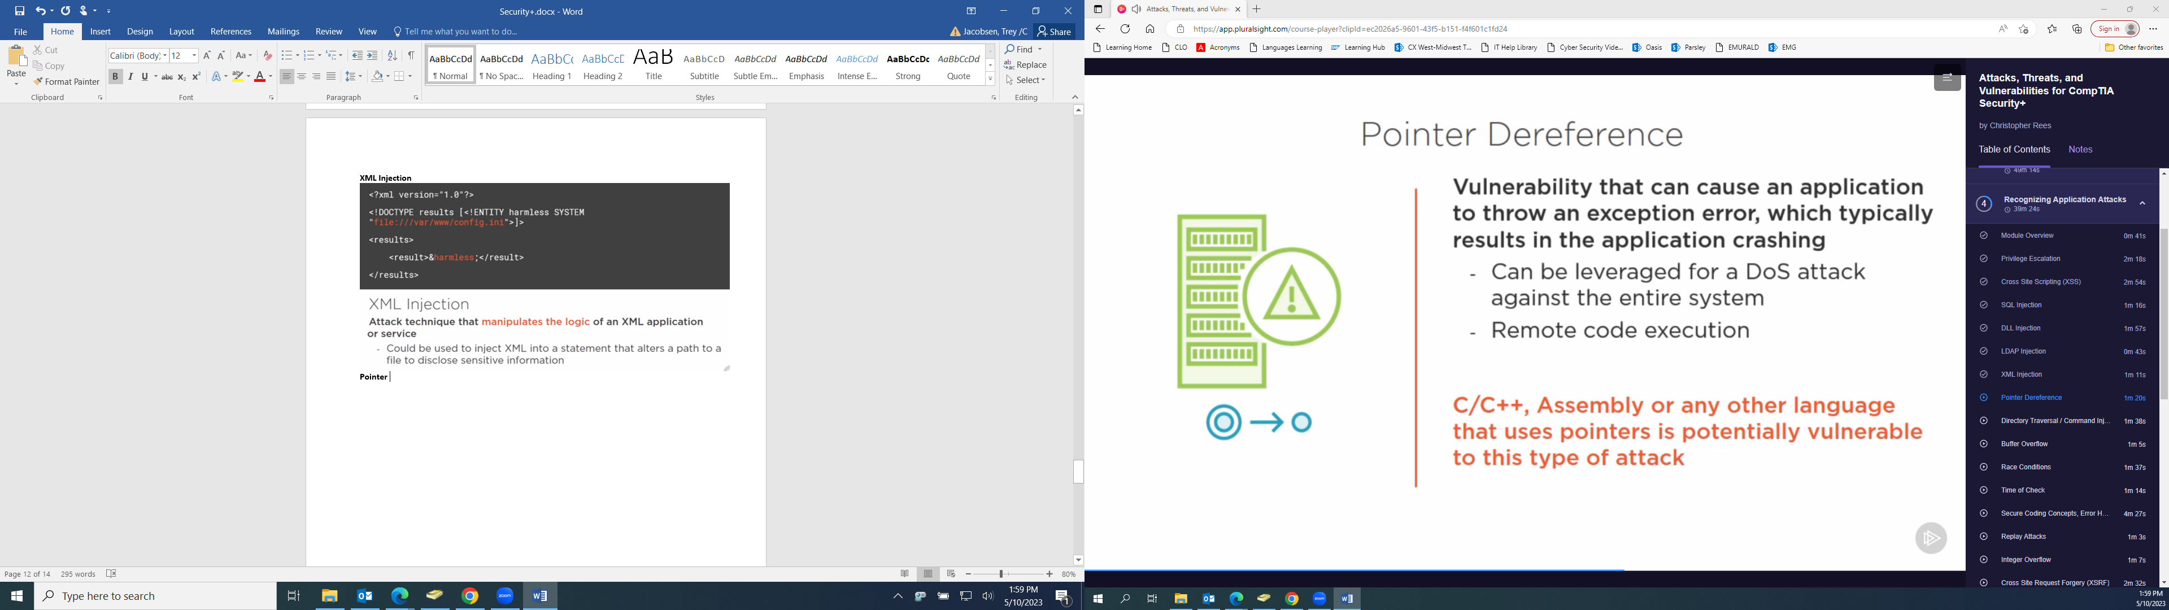

**Directory Traversal / Command Injection**

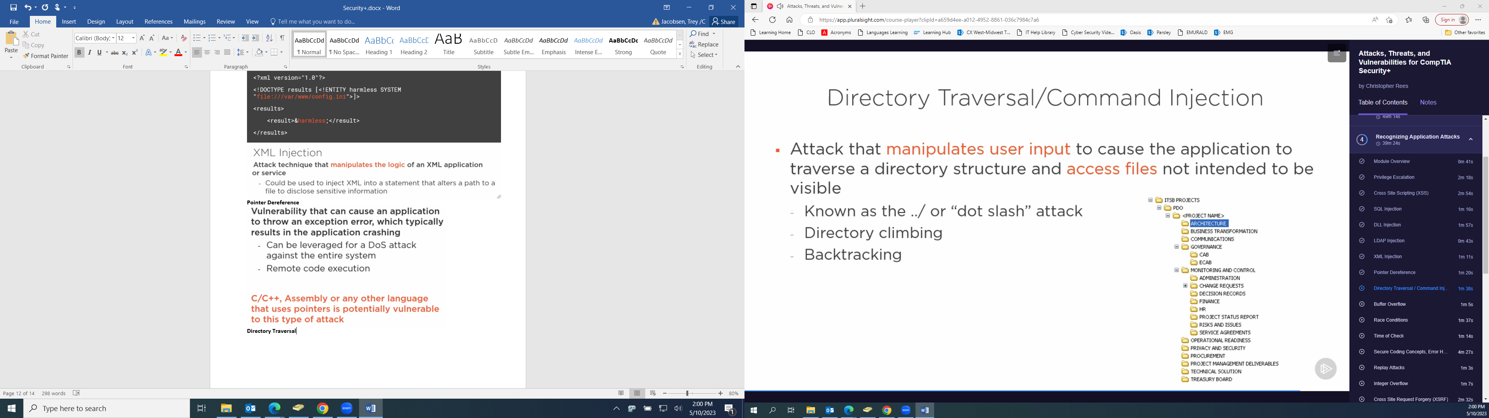

**Race Conditions**

